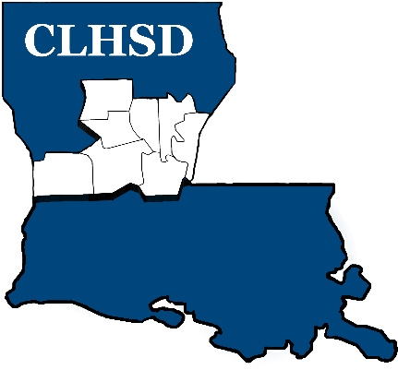

PUBLIC NOTICE
Meeting Cancellation

The Board of Directors of Central La Human Services District will not hold the June meeting:

We will be conducting board business at the next meeting, July 6th at 5:30

